- Fractions
1. Simplify 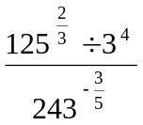 (3 mks)
2. Simplify without using calculators and tables
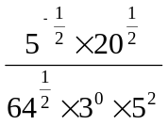 (3mks)
3. Evaluate without using a calculator. (3mks)
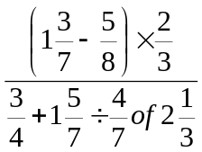
4. A two digit number is such that the sum of the ones and the tens digit is ten. If the digits are reversed, the new number formed exceeds the original number by 54.
Find the number. (3 marks)
5. Evaluate 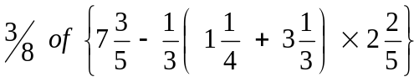 (3mks)
6. Convert the recurring decimal l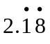 into fraction (3 mks)
7. Simplify 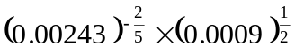without using tables or calculator . (3mks)
8. Evaluate without using tables or calculators (4mks)
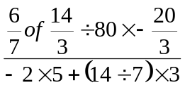
9. Mr. Saidi keeps turkeys and chickens. The number of turkeys exceeds the number of chickens by 6. During an outbreak of a disease, ¼ of the chicken and ¹/₃ of the turkeys died. If he lost total of 30 birds, how many birds did he have altogether? (2mks)
10. Work out 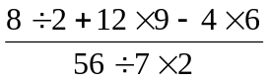 (2mks)
11. Evaluate -4 of (-4 + -5 ÷15) + -3 – 4 ÷2)
84 ÷ -7 + 3 - -5
12. (a) The recurring decimal 0.can be written as 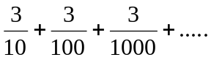
(i) Find the common ratio. (2mks)
(ii) Find an expression for the sum of n terms of this series. (3mks)
(iii) Find the 8th term of the series. (2mks)
(b) A ball is dropped from a height 30m above the ground and rebounds to ¾ of previous height continuously until it stops. Find the distance that the ball bounces when it hits the ground the 10th time. (ans to 2 d.p). (3mks)
END
END
13. Evaluate 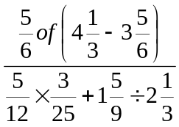without using a calculator. (3mks)

14. Without using tables or calculators evaluate.
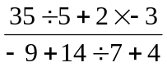 (4mks)
15. Without using tables or calculator, evaluate the following. (2 mks)
⁻8 + (⁻13) x 3 – (⁻5)
⁻1 + (⁻6) ÷ 2 x 2
16. Without using tables or calculator evaluate (3 marks)

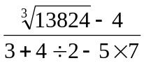
17. Express 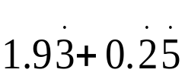 as a single fraction (3 marks)

18. Simplify ½ of 3½ + 1½ (2½ - ²/₃)
¾ of 2½ ÷ ½

19. Evaluate :
²/₅ ÷ ½ of ^{4/}₉ – 1¹/₁₀
¹/₈ – ¹/₆ of ³/₈

20. Without using a calculator or table, work out the following leaving the answer as a mixed
number in its simplest form:-
¾ + 1²/₇ ÷ ³/₇ of 2¹/₃
( ⁹/₇-³/₈ ) x ²/₃

21. Work out the following, giving the answer as a mixed number in its simplest form.
²/₅ ÷ ½ of ⁴/₉ – 1 ¹/₁₀
¹/₈ – ¹/₁₆ x ³/₈

22. Evaluate ;
³/₈ of 7³/₅ – ¹/₃ 1¼ + 3¹/₃ x 2²/₅

23. Without using a calculator, evaluate:
1⁴/₅ of ²⁵/₁₈ ÷1²/₃ x 24
2¹/₃ – ¼ of 12 ÷ ⁵/₃ Leaving the answer as a fraction in its simplest form

24. There was a fund-raising in Matisi high school. One seventh of the money that was raised
was used to construct a teacher’s house and two thirds of the remaining money was used
to construct classrooms. If shs.300,000 remained, how much money was raised

